Information

* Solution has two application named ContactManagementAPI and ContactOperations
* ContactOperations is a MVC application which is basically perform CRUD operation.
* ContactOperations is using backend as ContactManagementAPI web api.
* ContactOperations has logging feature implemented using singleton.
* ContactManagementAPI is a web api application which is using entity framework as repository for connecting to SQL server.
* In SQL server I have created one table with name ContactDetails
* Below are the table design :

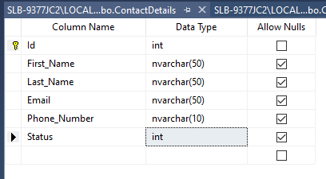

How to run the application:

* To run this application first you have to create a same structured table.
* Change the connection string from Web.Config file based on your DB structure.

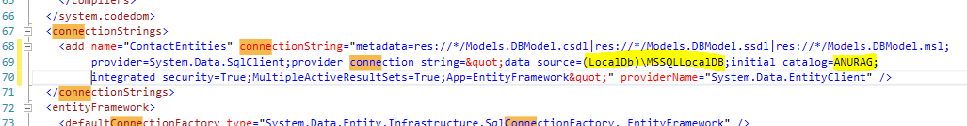

* Select both the project as startup and run the solution.

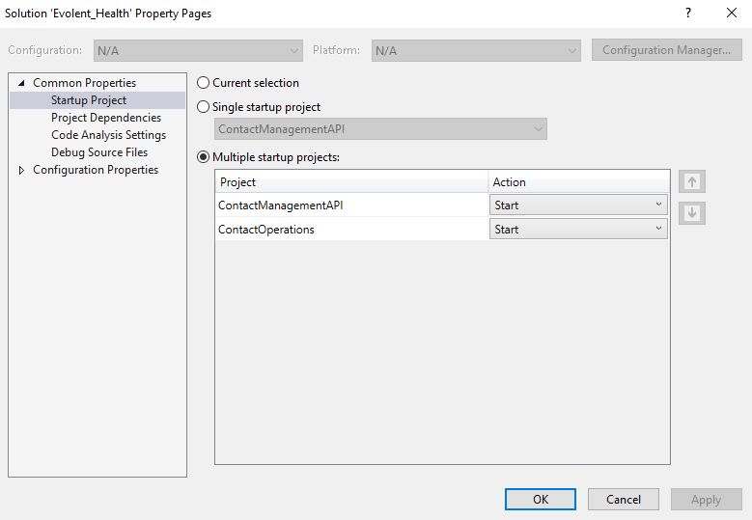

* Default routing will redirect you to the Index Action method and show the list of all the Contacts added.
* You can use Create New, Edit and delete button to perform other operations.
* This application does not have Login and logout feature which I could not do because of lack of time.